Chapter 1: Bits, Bytes and integers

Everything is bits(0 or 1)
It is much easier to save in memory
15213 -> 11101101101101

2 base float number
1.20
1 -> 2^0
2 -> 2^-1
0 -> 2^-2

1 Bytes = 8 bits

Example: Intel 64: the CPU can process 64 bits(8 Bytes) at one time.

Bits operation

Boolean Algebra(which is like sets)
1.And( & ):intersection
2.Or( | ):union
3.Not( ~ ):symmetric difference
4.Exclusive Or( ^ ):only 1^ 0/0^1 = 1:complement
*Compared with logical operators(&& || !)
They view 0 as false
Consider true or false in a certain period
“early termination”（逻辑短路）

Shift operation
<< left shift:
Throw away extra bits on the left (number of bits is limited)
Fill 0 on the right
>> right shift
1.logical shift:fill with 0 on the left
2.arithmetic shift: replicate most significant bit on the left
It is a important way to distinguish positive and negative number.
Number of shift < length of word
When number of shift > length of word: we shift:
(Number of shift) mod (length of word)
But in C, it will declare “undefined behaviour”

Integers: complement bit and unsigned bit
Positive or negative? Depends on the most significant bit(complement bit)
Which is called sign bit
1: negative
0: non-negative
Convert positive to negative(integer):
1.do ~ calculation in all bits
2.plus 1
The significant bit is weight as -2^n-1
Only lower n-1 bits are used to define positive integers.
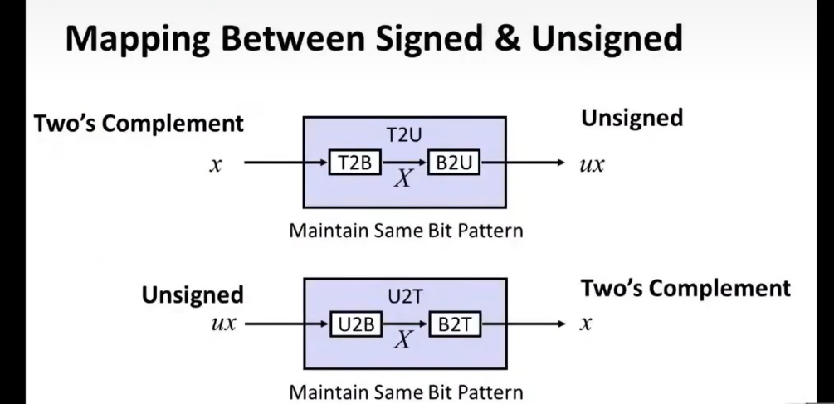
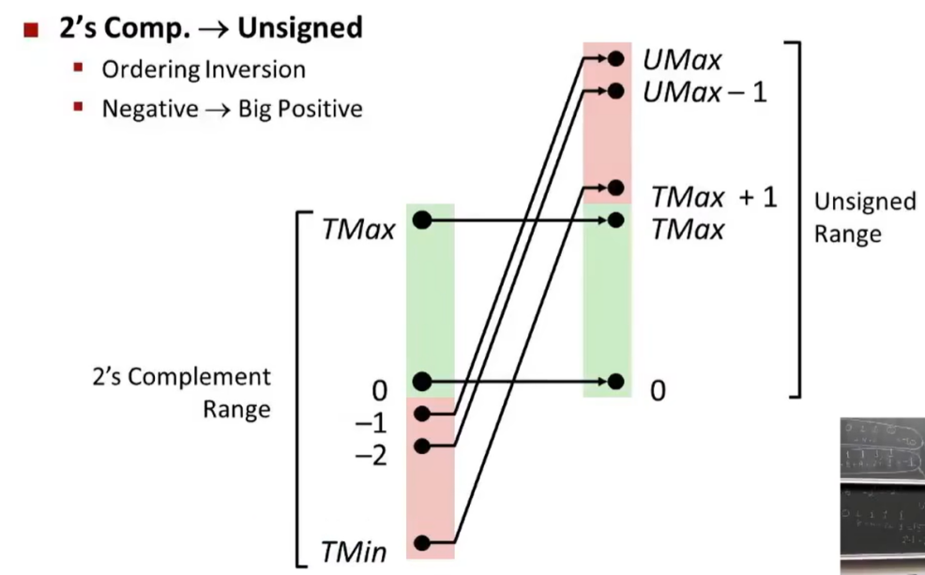
Bits perspective vs number perspective
Unsigned int in C: 10000U, 187478U...

Int tx;
Unsigned int ux;
tx = unsigned(ux)
ux = int(tx)

if unsigned and signed are in one single expression, signed value will implicitly cast to unsigned.(C)

Sign extension(4bits to 5bits for example)
6 -> 0110 -> 00110 -> still 6
-2 -> 1110 -> 11110 ->still -2
Extent the most significant bit.(calculate the example to prove it.)which is like mod calculation.(you just focus on the lower bits when you mod some 2 powers)

Unsigned addition
Pretty straightforward.
Check how much digits we need.
When overflow: minus 2^w to maintain in the range.
Subtraction -> add minus number

Signed addition: have to discard extra digits
Eg: 1011(-5) + 0111(7) = 10010 -> 0010 = 2
Int(unsigned + unsigned) == int + int
-> complement and unsigned have identical bit-level behavior

Overflow(): 4digits
7 + 5 = 0111 + 0101 = 1100 = -4 = 12 - 2^4

Unsigned multiplication:discard extra digits.
5 * 5 = 25 = 00011001 -> 1001 = 9
Signed multiplication
5 * 5 = 25 = 00011001 -> 1001 = -7 (sign bit)

Why unsigned number have to exist?
1.doing modular arithmetic
2.when using bits to represent sets

Memory organization:byte-oriented
Program refer to data from its address
Most machines use 64bits(8 bytes)as word size
(word is a chunk of bytes), addresses usually are the first byte in the word
So how are the bytes within multi-byte word ordered in memory?
Big endian vs little endian.
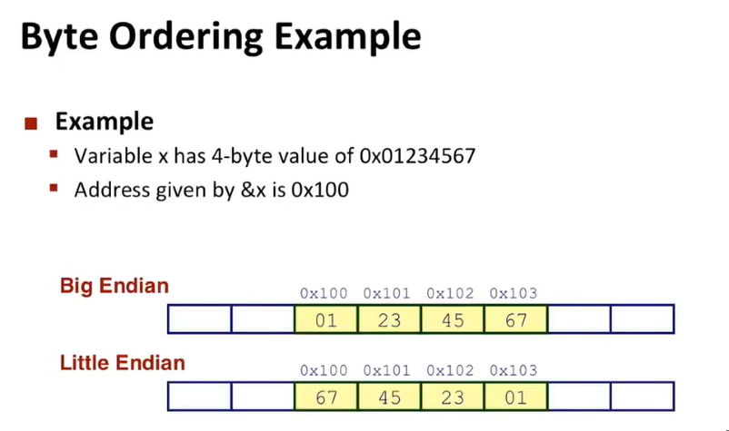

Different compilers -> assign different locations to objects

